**Can Making a Book Conserve a Forest? Bubango, Tanzania.**

Key Words: Conservation, Culture, Ethnobotany, Tanzania, Tradition.

When elders pass away, often their knowledge goes with them. We decided to create a booklet as a way to keep traditional information alive. We set out to make a collaborative record of Ha plant use (ethnobotany), in the village of Bubango, located in western Tanzania. Through community meetings, stemming from one of the author’s relationship with the community for over a decade, they wrote a letter of invitation for us to come and work with their community on this ethnobotanical project. We worked for three months daily with the village, and completed the booklet and presented the finished product at the end of this time period. The booklet itself is solely for the villagers and locals in the surrounding area. As the information is theirs, any further sharing of the product is at the locals’ discretion. The authors chose Bubango for this initial project, because this community had expressed interest over the years, and because of their proximity to important natural resources that would benefit from the community’s conservation awareness. The village borders the miombo woodland of Gombe Stream National Park and Lake Tanganyika. Gombe is a valuable strip of chimpanzee habitat made famous by the behavioral research program of Jane Goodall. Lake Tanganyika is a fresh body of water which supports abundant life and upon which many villages depend. As with any community living in forests, deforestation is almost always an issue. Although these villagers are conscious not to over cut for planting or to overhunt, forest loss is still a significant issue. When biodiversity declines, the ethnobotanical knowledge of the ecosystem drops as well. This reality seems to be affecting nearly all rural communities.This distancing diminishes peoples’ connection to the natural world, and thus their impetus to protect their environment. When people understand how to use their plants, the value of those particular species rises. Thus, when they value the plants, they also come to value the entire ecosystem, and place a greater emphasis on conservation.

continue to grow, the forest stays standing while also providing for the people.

We made sure to ask the children of Bubango if they wanted their pictures taken…we only had to pose that question once. To keep cultural/environmental information not only intact, but alive, the youth are the ones to carry this knowledge forward. (-4.8833, 29.6333, Photo by Maria Fadiman)



Children of the town of Bubango.



Woodlands once mantled this now denuded landscape. The locals used the trees for firewood and construction, and the land for farming. (-4.8833, 29.6333, Photo by Maria Fadiman)

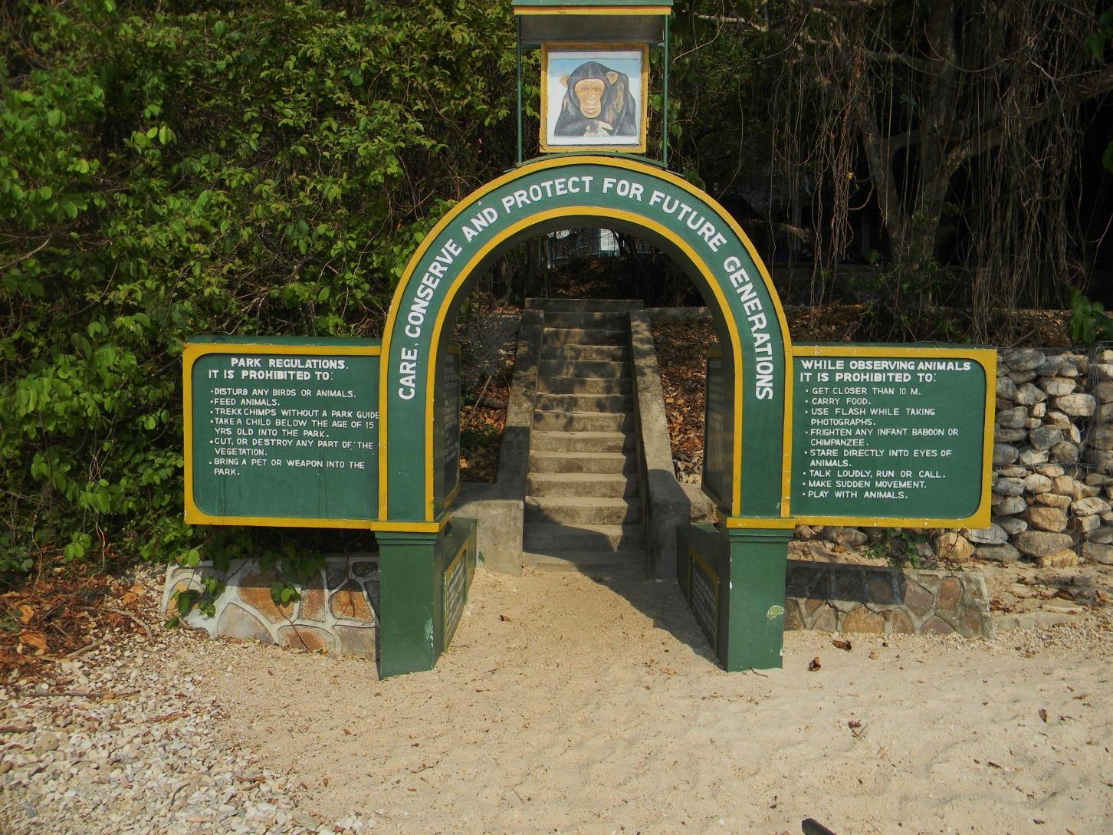

Gombe Stream National Park, the site of Jane Goodall’s chimpanzee research, borders Bubango, thus intensifying the need for conservation in this particular village. (-4.8833, 29.6333, Photo by Maria Fadiman)

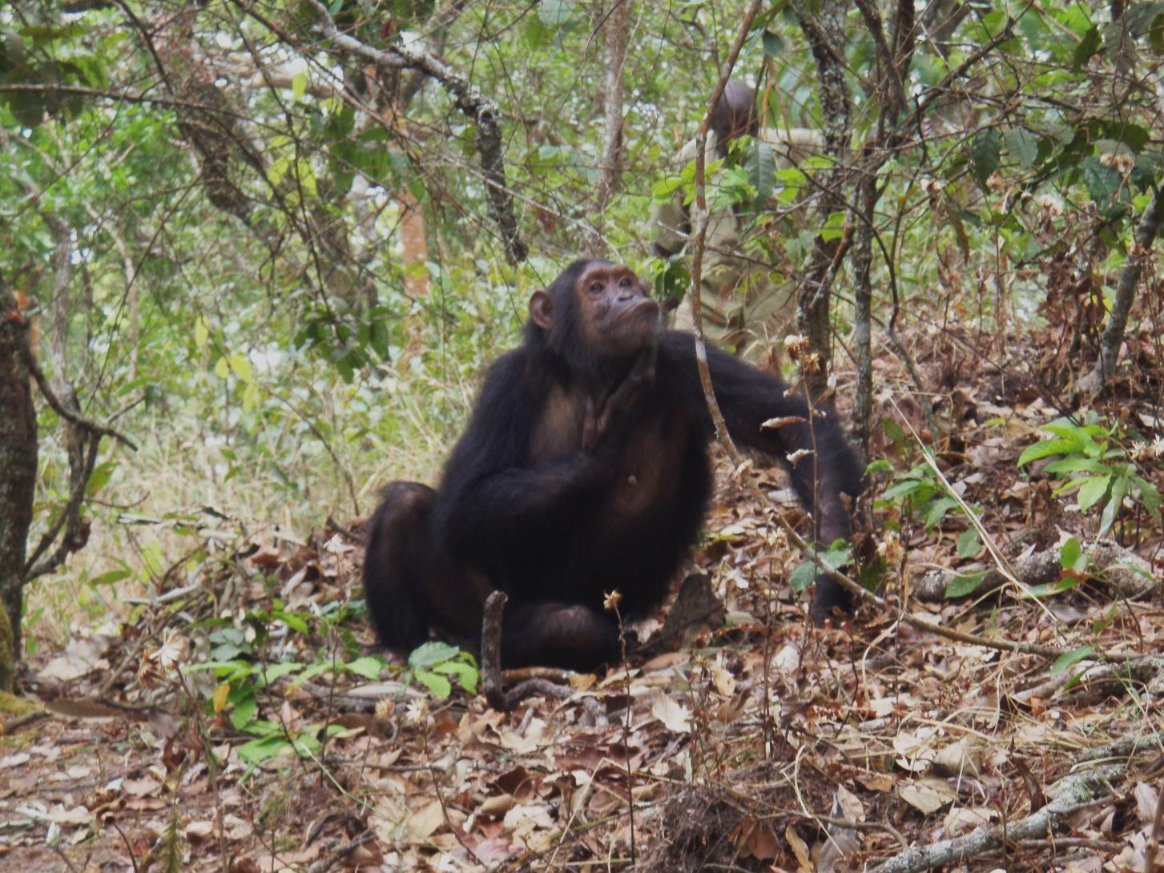



“I was told to keep my distance, but it was permissible for a chimpanzee to approach me.” This female and I locked eyes and she slowly began making her way towards me. As she came closer, she knelt down, picked up a huge rock and threw it at my head! My companion then told me “Oh right, don’t look them in the eye.” (-4.8833, 29.6333, Photo by Maria Fadiman)

We initially interviewed the elders to ask if they saw a reason to make an ethnobotany book. One man responded for the group, “Yes. The children only care about their cell phones.” (-4.8833, 29.6333, Photo by Maria Fadiman)

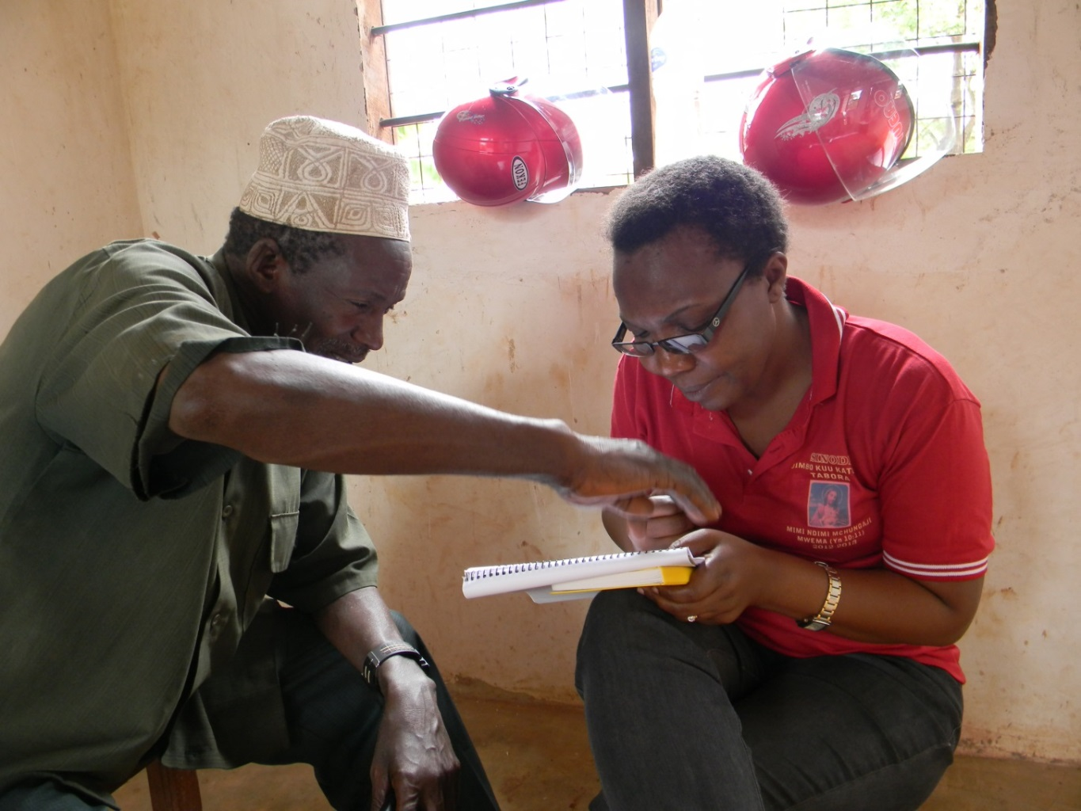

Grace interviews one of the elders about medicinal plants, as he corrects her. (-4.8833, 29.6333, Photo by Maria Fadiman)

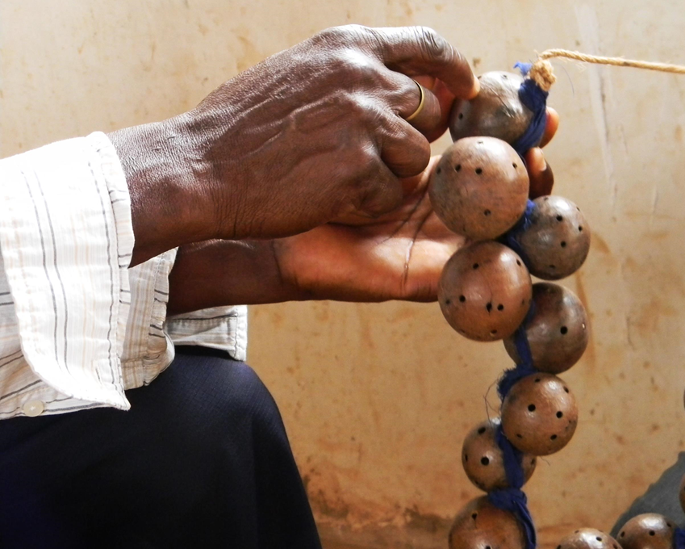

The book included plants employed for medicine, music, construction, cooking, and spirituality. In this example, the hard-shelled fruits of *Oncoba spinose* are filled with seeds and used as a musical instrument. (-4.8833, 29.6333, Photo by Maria Fadiman)

(-4.8833, 29.6333, Photo by Maria Fadiman)

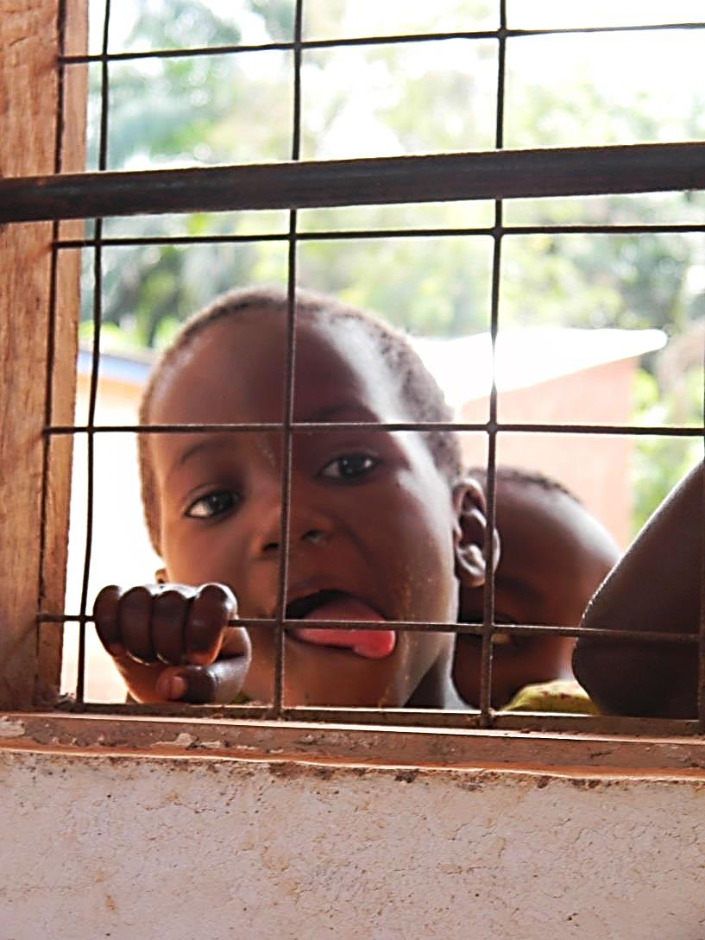

Child peeking as we interviewed his elders. We hoped that children’s curiosity in the process would interest them in the topic. (-4.8833, 29.6333, Photo by Maria Fadiman)

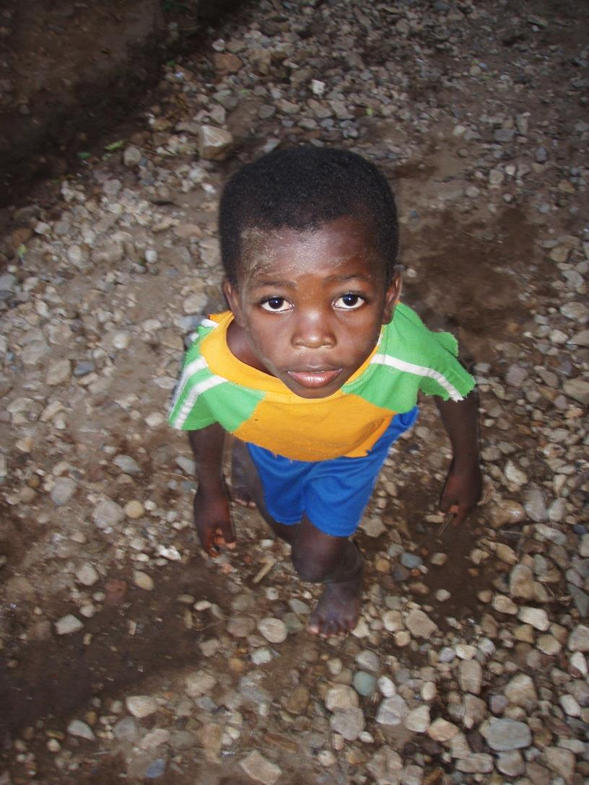

It did! We wanted the children to go beyond listening and become actively engaged in the production of the book. As depicted in this photo, we had their interest, and now we moved to the next step of directly involving them. (-4.8833, 29.6333, Photo by Maria Fadiman)



At the schools we asked “Who used plants today?” As they raised their hands they mentioned, “Food, animal feed, basketry and one talked about her boom made of grass. We had their attention, and they had ours. (-4.8833, 29.6333, Photo by Maria Fadiman)

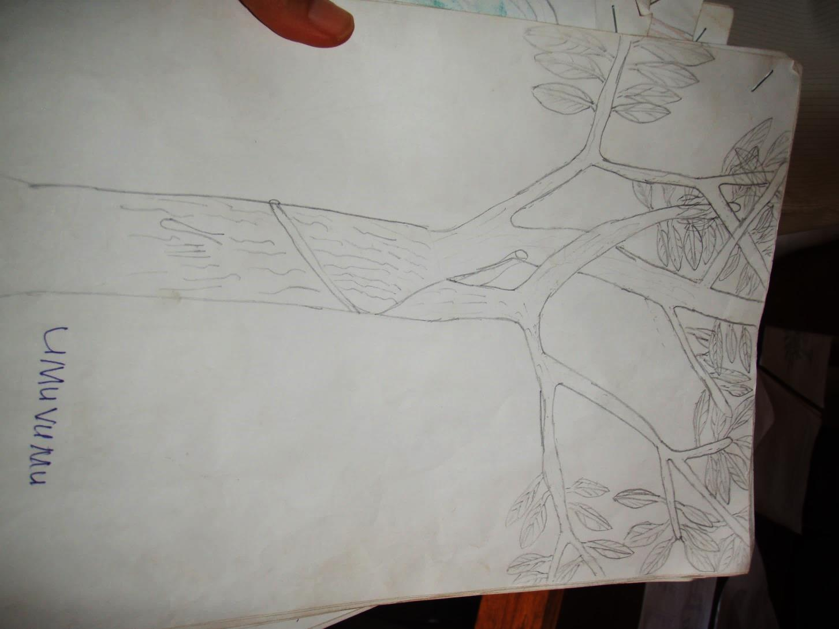

The school children illustrated and named plants, connecting them to useful plants, traditional language, ecosystem use, and the book. (-4.8833, 29.6333, Photo by Maria Fadiman)

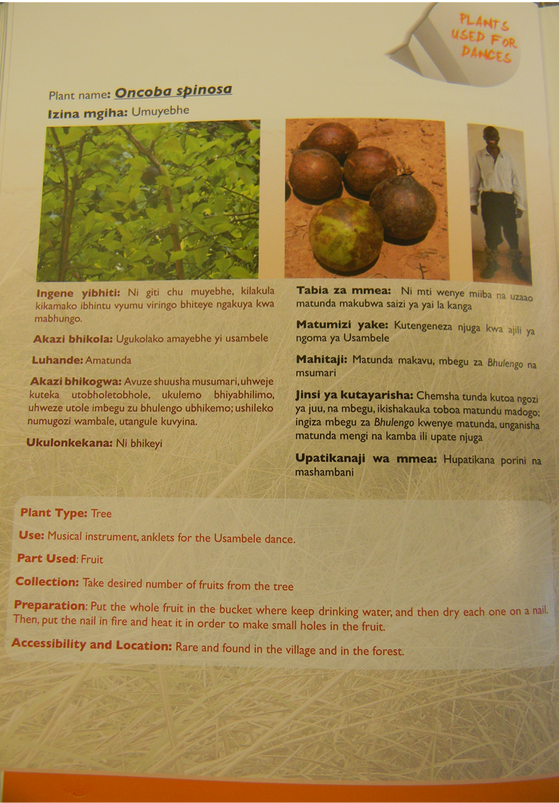

Here is an example of a page from the final product. The first description is in Kiha, their tribal language, second in Kiswahili and last, in English. (-4.8833, 29.6333, Photo by Maria Fadiman)

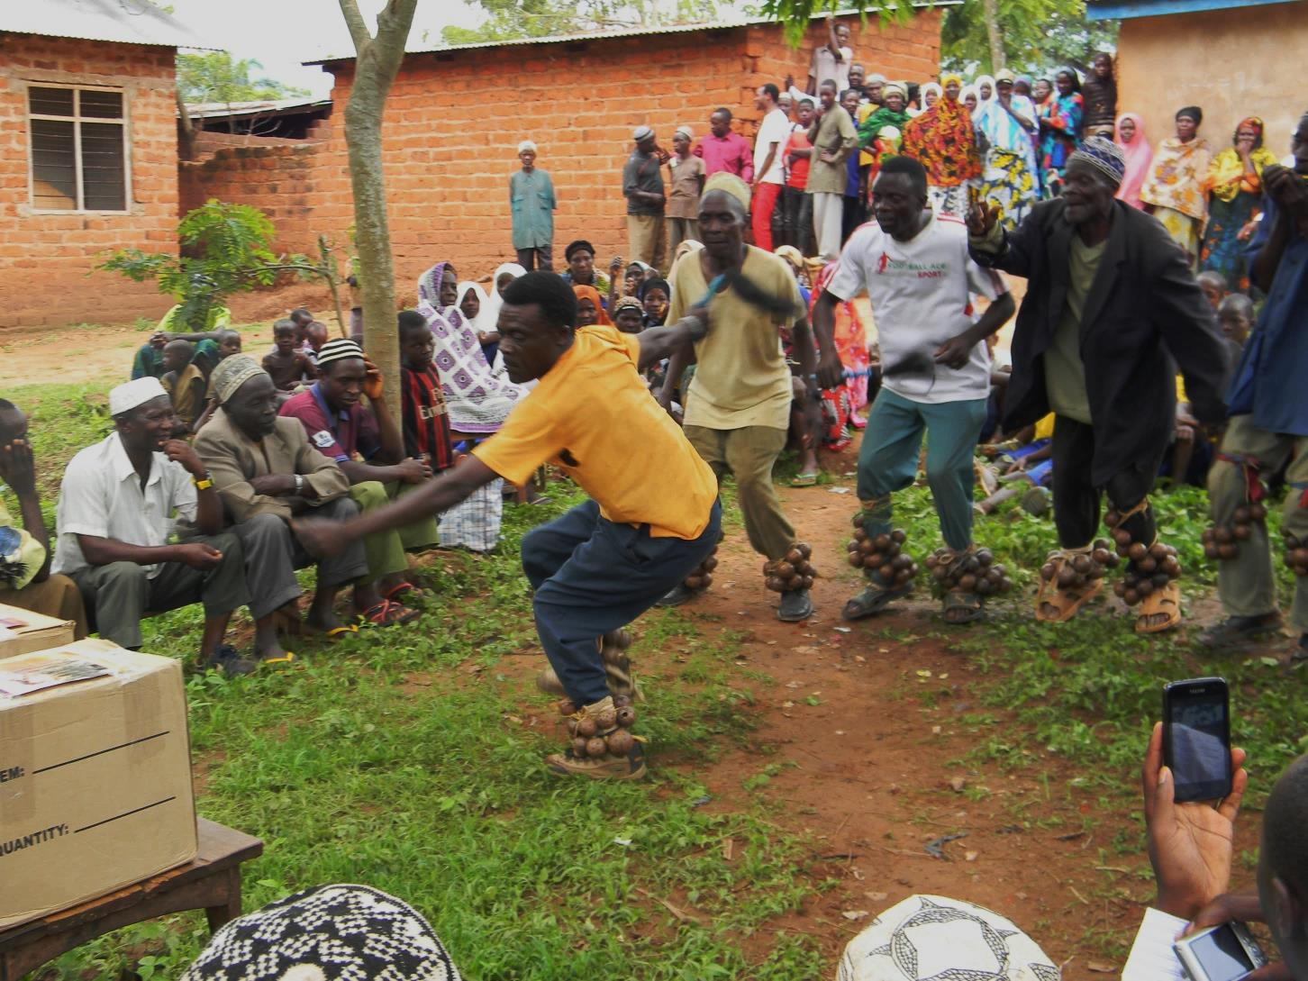

To celebrate the event’s importance, a musical ceremony accompanied the book presentation. Note the musical instruments on the dancers’ ankles. (-4.8833, 29.6333, Photo by Maria Fadiman)

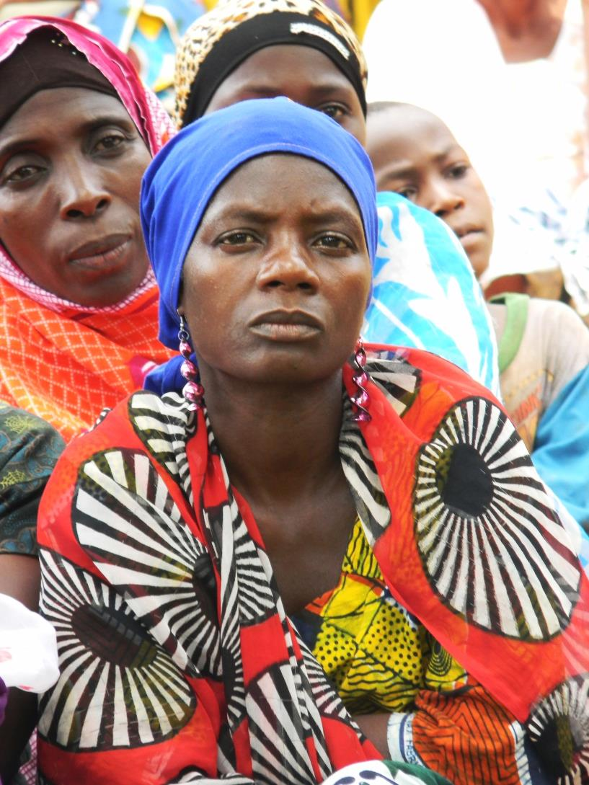

Villagers watched, becoming absorbed in the event. (-4.8833, 29.6333, Photo by Maria Fadiman)

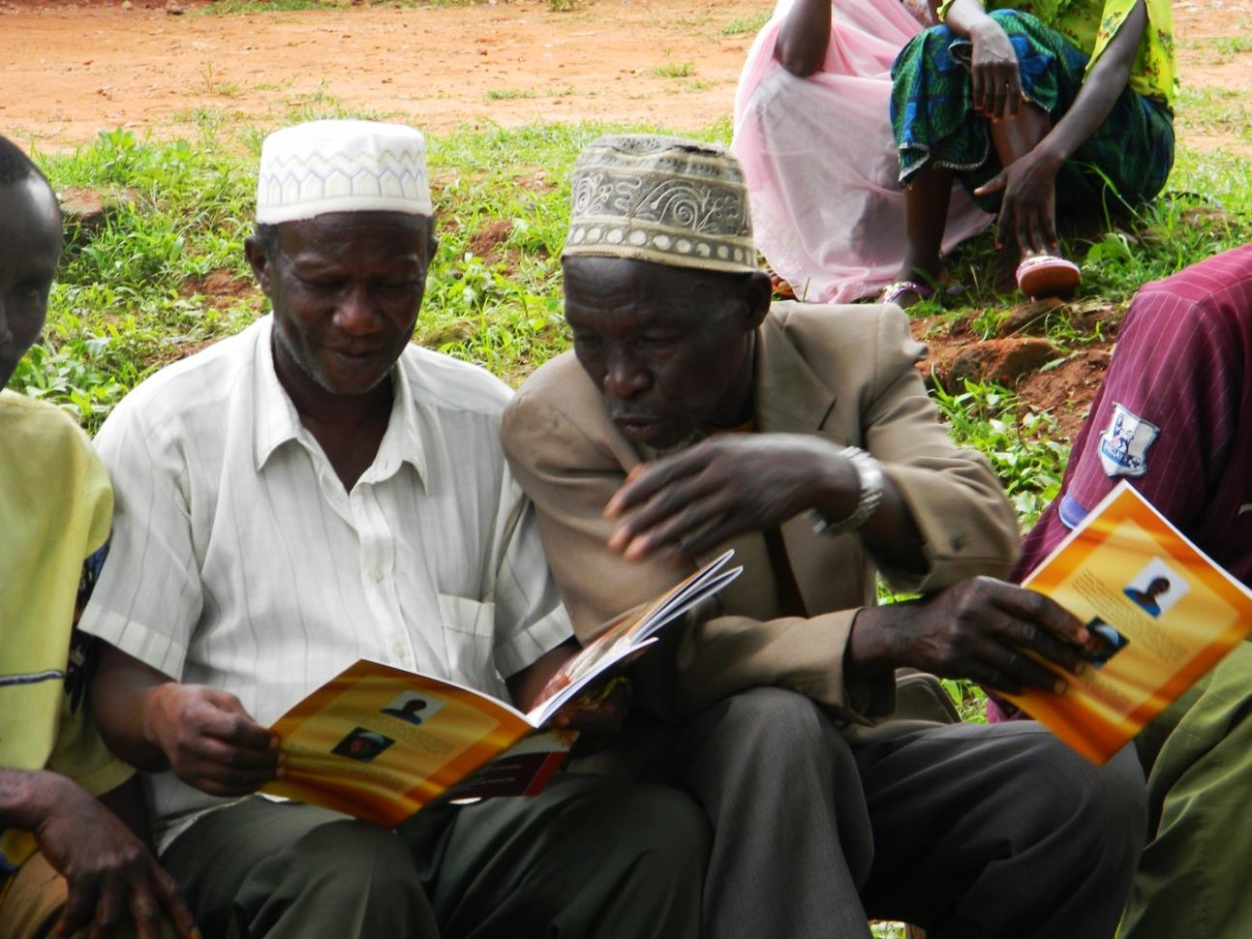

Ethnobotanical experts with their books are seeing their own words, in their own language, in print, for the first time. Keeping this information alive beyond the pages, they continue to discuss the content. (-4.8833, 29.6333, Photo by Maria Fadiman)

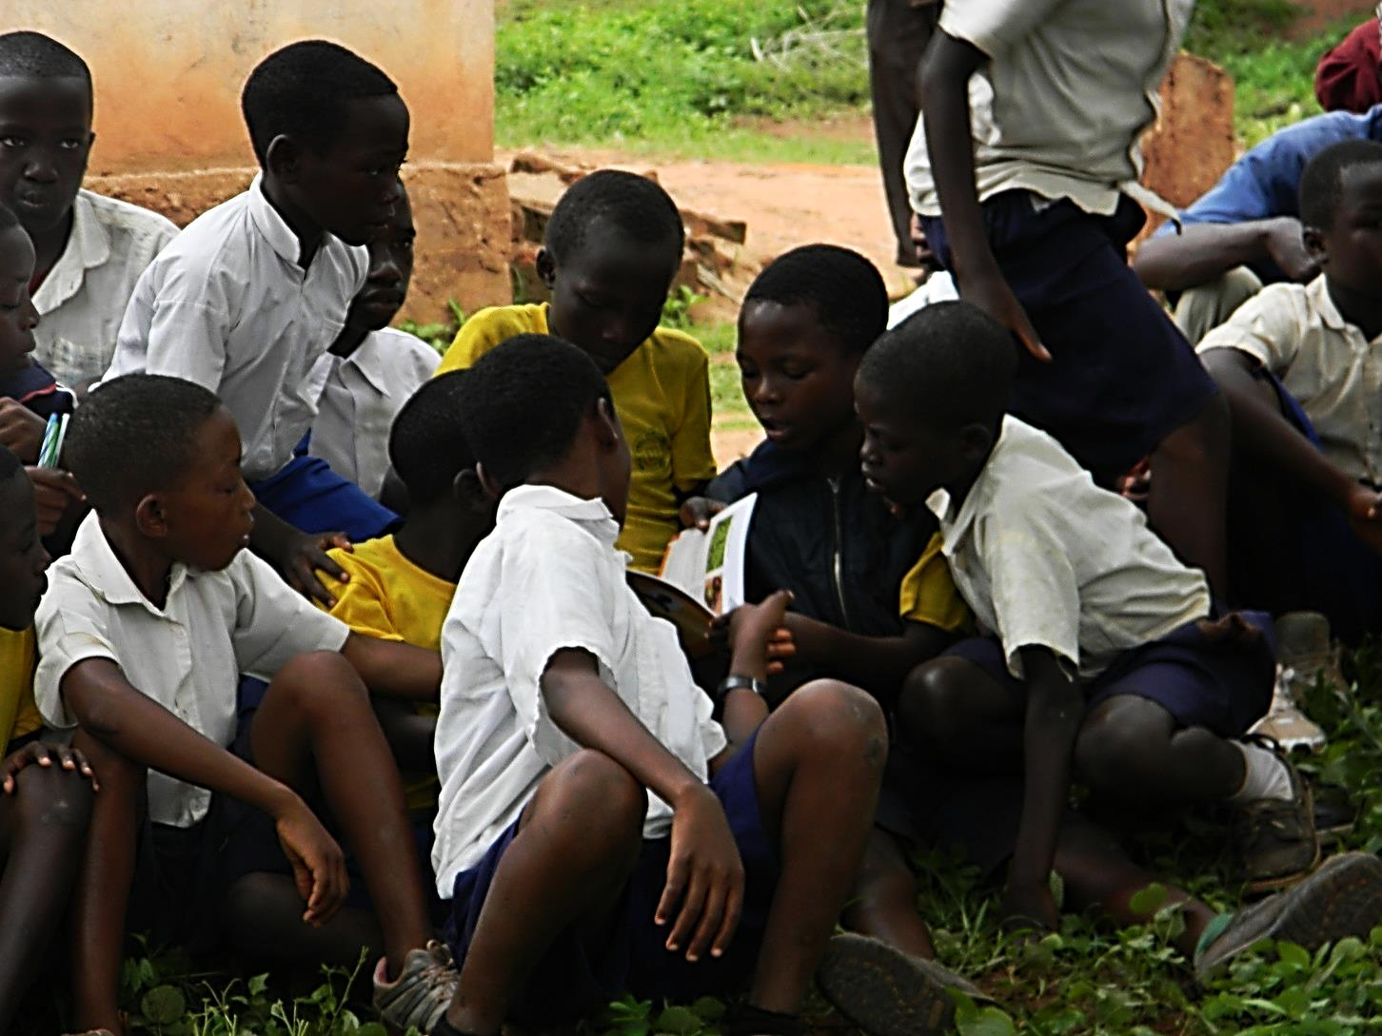

The children seeing the book for the first time. They were excited seeing plants they recognized, and proud of their own contributions. (-4.8833, 29.6333, Photo by Maria Fadiman)

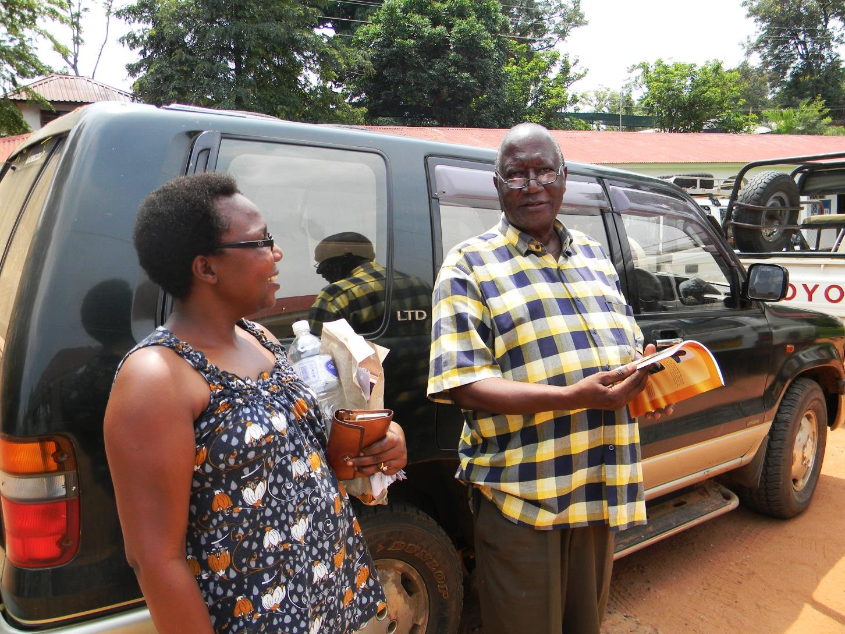 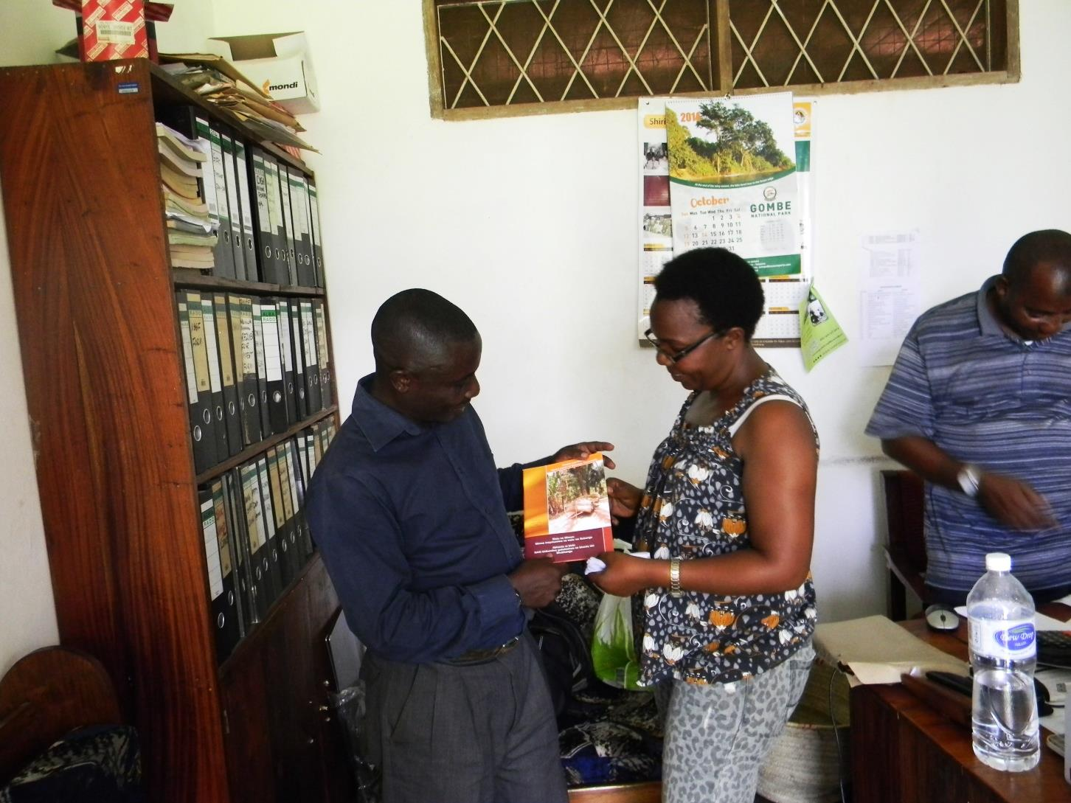

Interest in the book extended into the town of Kigoma. A western-trained doctor asked for a copy (above), as well as representatives of the Jane Goodall Institute (below). (Kigoma, Photo by Maria Fadiman)

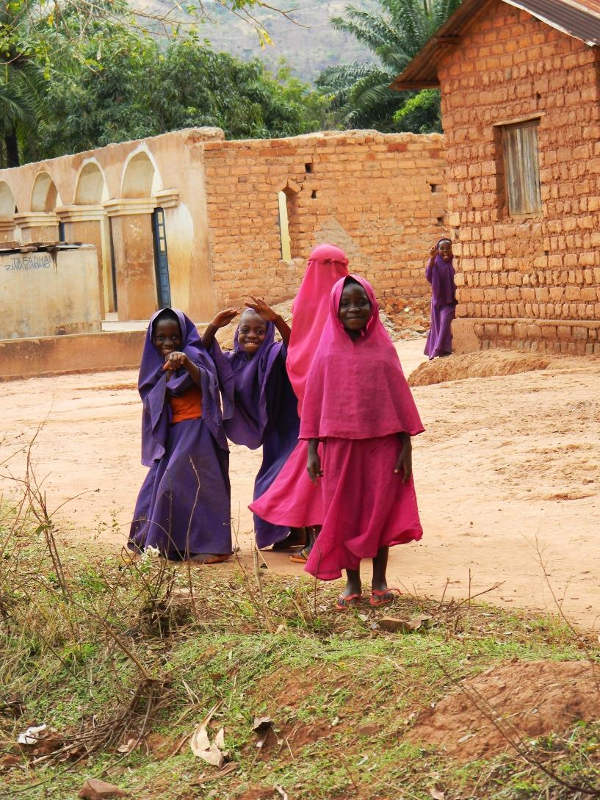

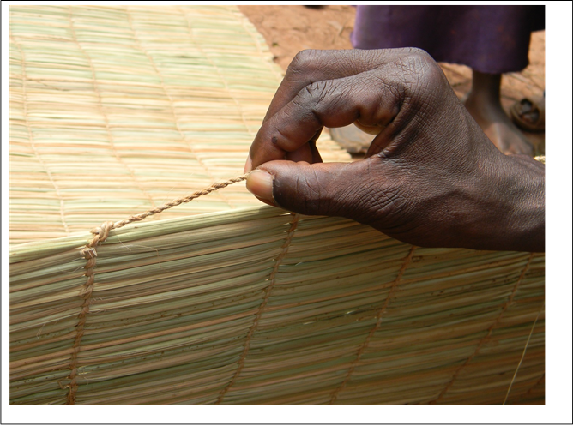

The neighboring village of Mwamgongo requested that we help them create their own books. We returned the next year, and were able to complete a similar project with them and their specific information. (Mwamgongo, Photo by Maria Fadiman)

People value what they use, and use what they know. If they are able to utilize plants in local forests, people are more likely to see the value of habitat protection. (-4.8833, 29.6333, Photo by Maria Fadiman)

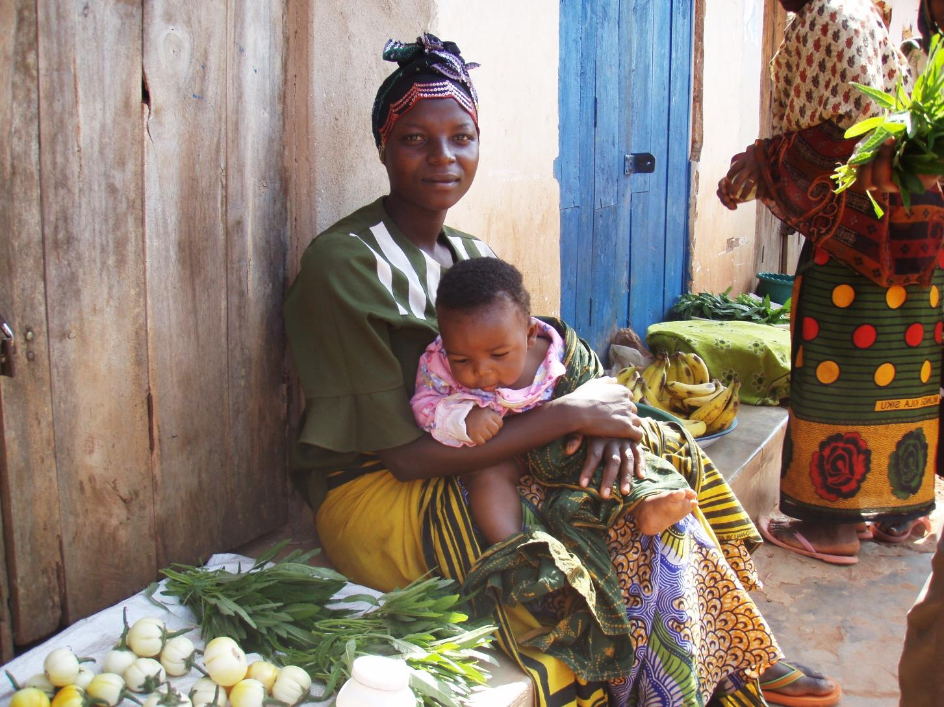

Awareness of the value of ethnobotany peaked during book production. Whether it will have a lasting effect on the next generation remains to be seen. (-4.8833, 29.6333, Photo by Maria Fadiman)

Compiling a booklet describing people’s plant knowledge as a method of sustaining their knowledge and thus motivating conservation, begs the question…will it work? A written record now exists, so the ethnobotanical information will not be lost. The book is aesthetically pleasing, and is accessible even to those who are illiterate. Having the first language in the book written in their tribal language, Kiha, turned out to be even more important that we imagined at the outset. We also learned that having the process be so public drew more people into participating. In the short term, the project definitely achieved the intended goals of stimulating cultural knowledge and ecosystem awareness. Follow up studies such as plant list checks, age of villagers in reference to plant knowledge, and looking at the number of people in the village with general and specific ethnobotanical knowledge, will determine whether this sort of undertaking will translate in the longer term into conservation drivers.

**Acknowledgments and Authors**

We would like to thank the people of Bubango, especially the Village Chairperson, Village Executive Officer and the individuals who shared their knowledge. We also want to thank the National Geographic Genographic Legacy Fund, the National Geographic Emerging Explorers Program and the Jane Goodall Institute; special thanks also go to Kate Detwiler for helping to facilitate this collaboration, Frank Mbago of the herbarium of University of Dar es Salaam and Roy Gereau of Missouri Botanical Garden for helping in the identification of certain specimens, Joseph Nyrenda for editing the Swahili version and Martin Gobbo for his book graphics.

Maria Fadiman, Associate Professor at Florida Atlantic University in the Geosciences.

[mfadiman@fau.edu](mailto:mfadiman@fau.edu)

Grace Gobbo, Consultant with the Tanzania Botanical Research and Conservation Program.

[Gracunga5@yahoo.com](mailto:Gracunga5@yahoo.com)